**The Battle of the Neighborhoods**

Ramon Lopez

June 24, 2020

**1. Introduction**

**1.1 Background**

In the United States there is millions of businesses and out of those businesses there is thousands of restaurants. As a restaurant you want to grow and build new restaurants in other places around the country or be able to relocate to somewhere more profitable if need be. You usually want to relocate or build a restaurant near cities as it can be very profitable with the abundance of customers in a city. The problem that comes with having a restaurant in a city is more competition and a lot of potential crimes. Which makes it important to find which neighborhoods would be best to relocate or build a restaurant that would have the minimum amount of crimes and competition.

**1.2 Problem**

The problem for this project will be that a restaurant owner wants to be able to relocate to New York City. The first reason why they want to relocate is due to crimes that have happen to the restaurants like robberies and burglaries. Second reason is they want to be able to have a better opportunity to expand and grow the restaurant without having to worried about a lot competition. Which leads to the question what borough and neighborhood would be best for them to relocate their restaurant to.

**1.3 Interest**

This project would be of interest of restaurant owners that are worried about crimes and competition when wanting to either relocate or build a restaurant in New York City. It might have some interest for New York law enforcement to see which boroughs and neighborhoods have abundance of crime.

**2. Data Acquisition and Cleaning**

**2.1 Data**

Data used for this project was Foursquare location data, NYC crime and geographic information system (GIS) data. Foursquare is a technology platform that has a massive location data set and it will be used to find the different venues in each neighborhood. The NYC crime data was obtained from NYC Open Data and the data was provided to them from the police department. The data was used to find the borough and neighborhood that is safest. A NYC neighborhood json file was obtained from NYU Spatial Data Repository used to get the neighborhoods so I can obtain the venues. Lastly the GIS data was obtained from NYC Open Data. The data will be used to get the boundaries for each borough so choropleth maps can be created.

**2.2 Data Cleaning and Feature Selection**

The data was obtained from different sources and was separated into two different tables. The first table being crime related data and the second table being venue related data. The data was separated into two tables to make the notebooks and the EDA more organized.

The crime data was huge with 108,058 rows and 35 columns. I dropped 30 columns due to those columns having zero relevance to the problem at hand. I kept the columns BORO_NM, OFNS_DESC, PREM_TYP_DESC, Latitude, and Longitude. The columns were renamed to Borough, Crime Committed, Location of Crime, Latitude, and Longitude. The reason why these columns were chosen was because I needed the borough, latitude and longitude where the crime was committed so I can plot where the crime was committed and perform EDA on the boroughs regarding the crimes committed. While Crime Committed and Location of Crime was used to filtered out the crimes I needed and to get the locations needed. Then I created a crime list of crimes that would affect a restaurant for example robbery, burglary, grand larceny and similar crimes. I used the list to filter those specific crimes and I filtered the Location of Crime column to get the crimes that were committed in a restaurant. At the end the crime data set had 685 rows and 5 columns.

For the venue data I had to obtain the neighborhood latitude and longitudes to get the venues for each neighborhood. I used a json file from NYU Spatial Data Repository to obtain the neighborhood and the corresponding latitudes and longitudes. I created a table of 306 rows and 4 columns with the columns being Borough, Neighborhood, Longitude and Latitude. Using the data of the neighborhoods and Foursquare I used a function to pull the venues for each neighborhood within a 500-meter radius and venue limit of 100. The function then creates a new DataFrame for each borough using the information obtained and combining the previous neighborhood DataFrame. This new venue DataFrame contains the following columns Neighborhood, Borough, Neighborhood Latitude, Neighborhood Longitude, Venue, Venue Latitude and Venue. Longitude. Lastly, I combined all the venue DataFrames into one DataFrame which contains 4168 rows and 7 columns.

**3. Exploratory Data Analysis**

**3.1 Neighborhood and Venue Distribution**

I wanted to see the distribution of neighborhoods between the boroughs and how the number of neighborhoods would have a correlation with the number of venues. I created bar plots and different types of maps like a map of each venue / neighborhood and choropleth map.

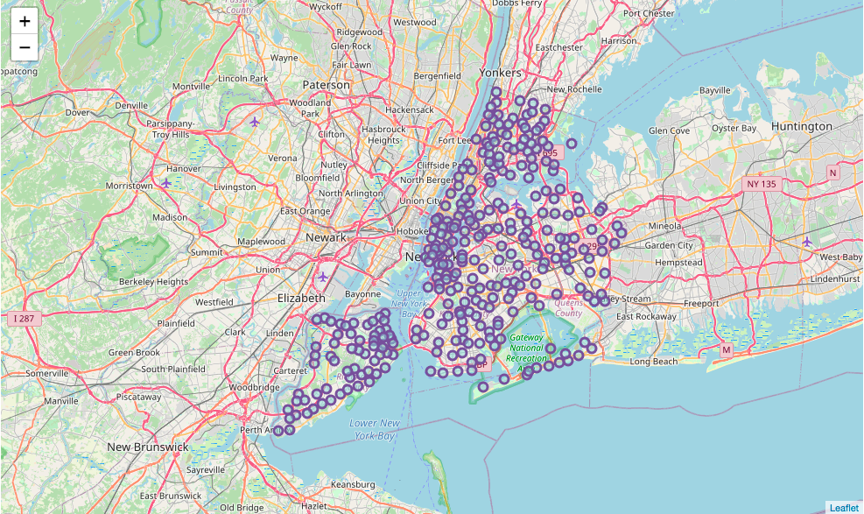

Figure . Map of distribution of neighborhoods across boroughs

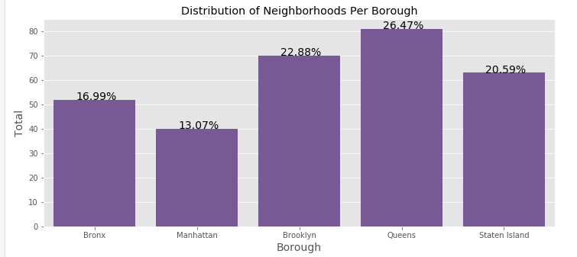

Figure . Bar plot of the distribution of neighborhoods per borough

I found that the neighborhoods distribution was spread fairly even across the boroughs except Bronx and Manhattan. These two boroughs had the lowest number of neighborhoods with Manhattan having a total of 40 neighborhoods or 13.07% of the total amount of neighborhoods were within Manhattan. While Queens, Brooklyn and Staten Island had the three highest totals with Queens having the highest amount of 81 neighborhoods or 26.47% of the total neighborhoods.

I used the venue distribution to see which borough has the least amount of competition and to see if number of neighborhoods had a correlation between the number of venues. I used a bar plot and choropleth map to show the distributions. I found that the amount neighborhoods don’t necessary correlate with the number of venues. For example, Manhattan had the lowest number of neighborhoods but had the highest number of venues with 36.13% of the total amount of venues belonging to Manhattan.

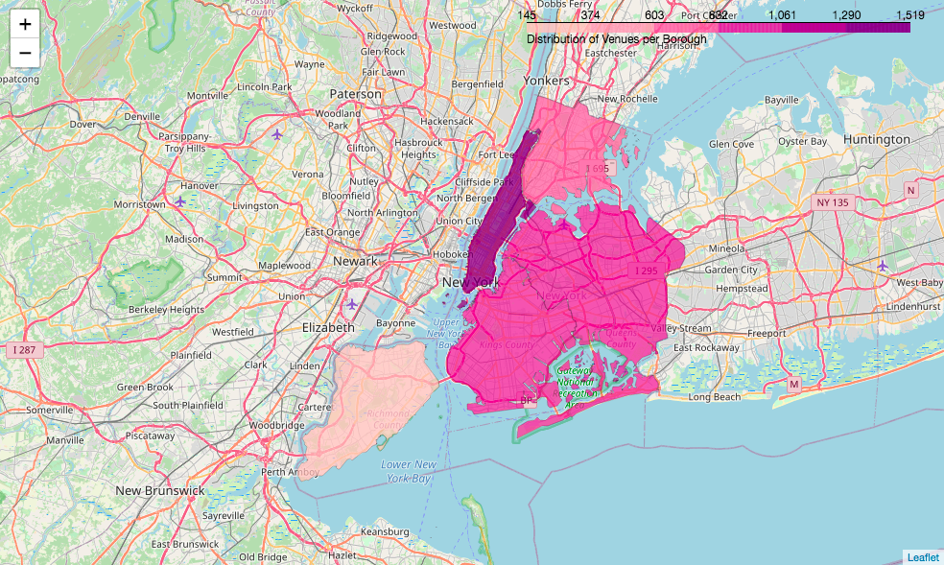

Figure . Choropleth map of distribution of venues per borough

As stated before, in the graph Manhattan has the greatest number of venues with a total of 1506. Staten Island has the lowest amount of venues with a total of 158 despite having the third highest number of neighborhoods. This shows that Staten Island has the least amount of competition. Shown in Figure 5 is the most common restaurants in NYC. I wanted to see what kind of restaurants are most common and if you were owner you can see what the competition is like before building or relocating your restaurant.

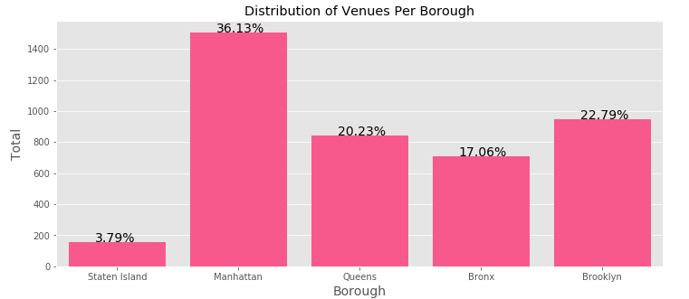

Figure . Bar graph of distribution of venues per borough

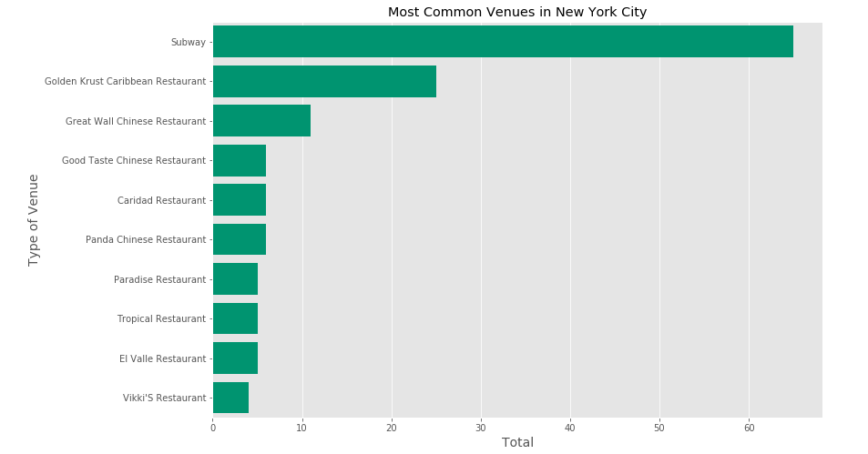

Figure . Bar graph of the ten most common restaurants

**3.2 Distribution of Crime Data Across the Boroughs**

The other key problem was to see which borough had the highest amount of crime. I decided to tackle this problem by finding the distribution of the number of crimes throughout the boroughs. I created multiple maps and bar graphs to see distribution of crime total and crime types.

First, I wanted to see an overall view of all the crimes in each borough, so I created a map (Figure 6) to visualized this. Each color dot corresponds to a type of crime so each type can be distinct from each other. Here is a table with type of crime and its corresponding color that shows up in the map (Table 1). In Figure 7 I created a choropleth map of the total crime distributions across each borough to get a clearer look at which borough had the most crime and which had the least.

Table . Crime type and the corresponding color

|  |  |
| --- | --- |
| Type of Crime | Color |
| Grand Larceny | Red |
| Burglary | Purple |
| Criminal Mischief | Cyan |
| Other Offenses Related to Theft | Light Green |
| Robbery | Blue |
| Criminal Trespass | Olive |
| Arson | Orange |

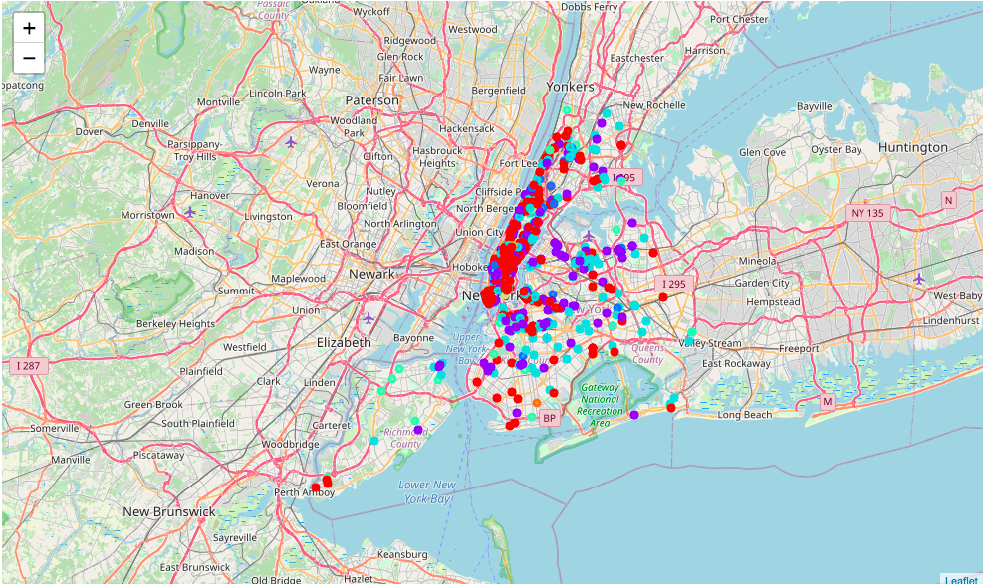

Figure . Map of total crime distribution

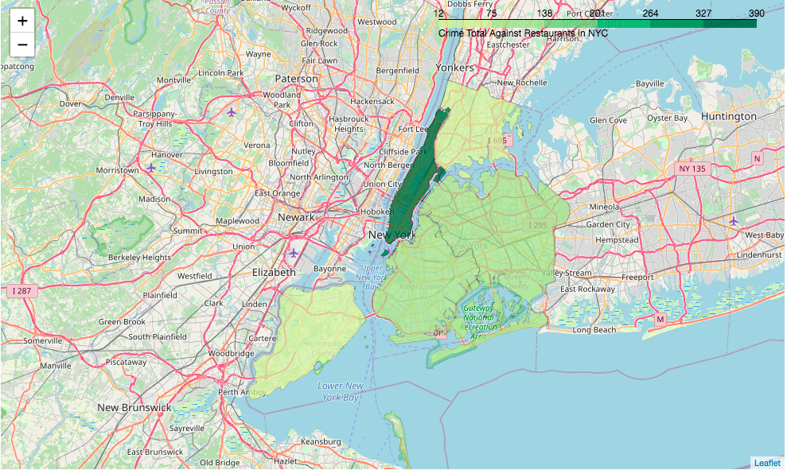

Figure . Choropleth map of total crime distribution

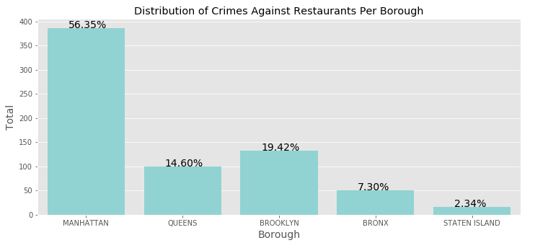

Figure . Bar graph of total crime per borough

Looking at the Figure 7 and 8 it is clear that Manhattan has the highest total crime with a total of 386 crimes. Another way of looking at it is 56.35% of all crimes against restaurants in NYC happen in Manhattan. On the other side of the spectrum Staten Island has the least amount with a total of 16 crimes or 2.34% of the total crimes. After seeing the distribution of the total crimes, I wanted to see the distribution for each type of crime. I found that the most common type of crime is Grand Larceny and the least common was Arson. It was also found that the majority of the crimes committed were from three types of crimes which were Grand Larceny, Burglary and Criminal Mischief and Related.

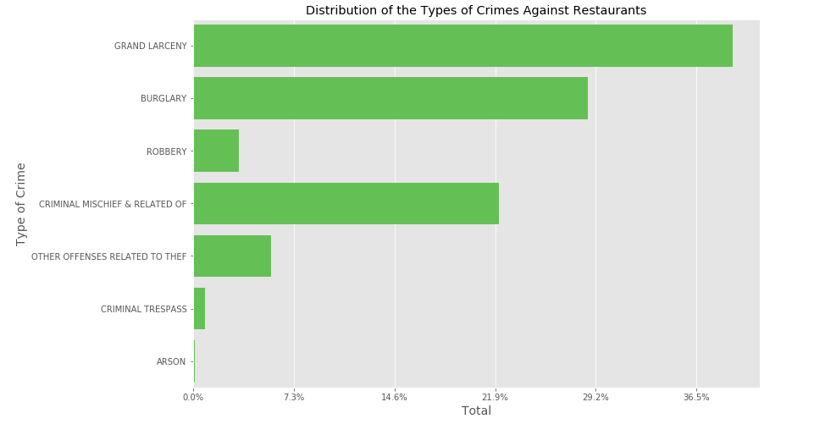

Figure . Bar graph of distribution of crime types

Lastly regarding distribution of crimes, I wanted to see the total amount of each crime type per borough. I wanted to gain insight about which borough had more dangerous crimes like Burglary, Robbery or Arsonand which had less dangerous crimes like Criminal Mischief. I found interesting information during the analysis which is displayed in Figure 10. I found that Manhattan most common crime was Grand Larceny and it had the highest total of Grand Larceny out of all five boroughs. Manhattan also had the highest amount of all categories besides Arson. Right behind Manhattan was Brooklyn which was second in Grand Larceny, Burglary, Criminal Mischief and Other Offenses Related to Theft. Also, it was the only borough to have an arson committed against a restaurant. Queens was third in most categories but had the least amount in the category Other Offenses Related to Theft. Bronx was in the bottom half of all of the categories besides Robbery which it had the second highest amount. At last Staten island was at the bottom of all categories with either little or no crimes committed except for Other Offenses Related to Theft which it had the third highest.

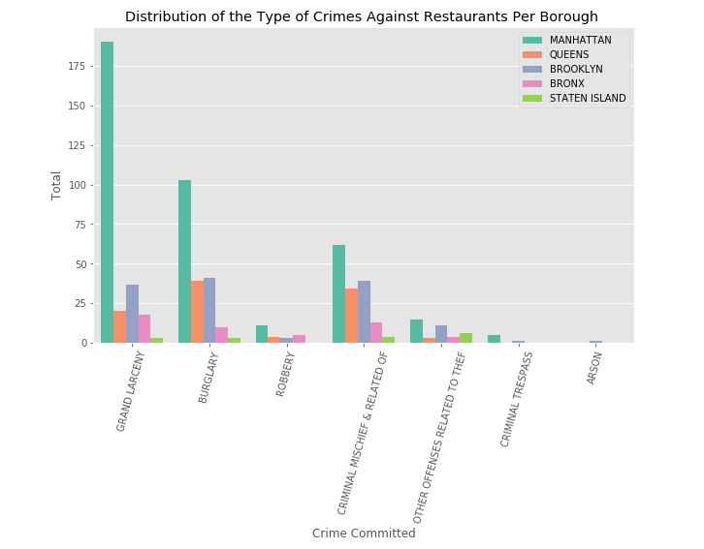

Figure . Distribution for each type of crime per borough

**3.3 Crime Rate for Each Borough**

Judging a borough purely off distribution doesn’t tell the full story. For example, Manhattan has a lot of restaurants so that might be a reason why it has such a high total amount of crime. To solve this potential problem, I wanted to do an analysis of the rate of crime for each borough. To calculate this, I took the total crime for each borough and divided it by the total number the respective borough had and then multiplied it by 100 to get per 100 restaurants. The results were a little surprising, turns out Manhattan had the highest with a rate of 25.6 crimes committed per 100 restaurants. What I didn’t expect was that Bronx would actually have the lowest with a rate of 7.0 crimes committed per 100 restaurants. Staten Island had a rate of 10.1 per 100 restaurants while Brooklyn was second highest and Queens was third highest.

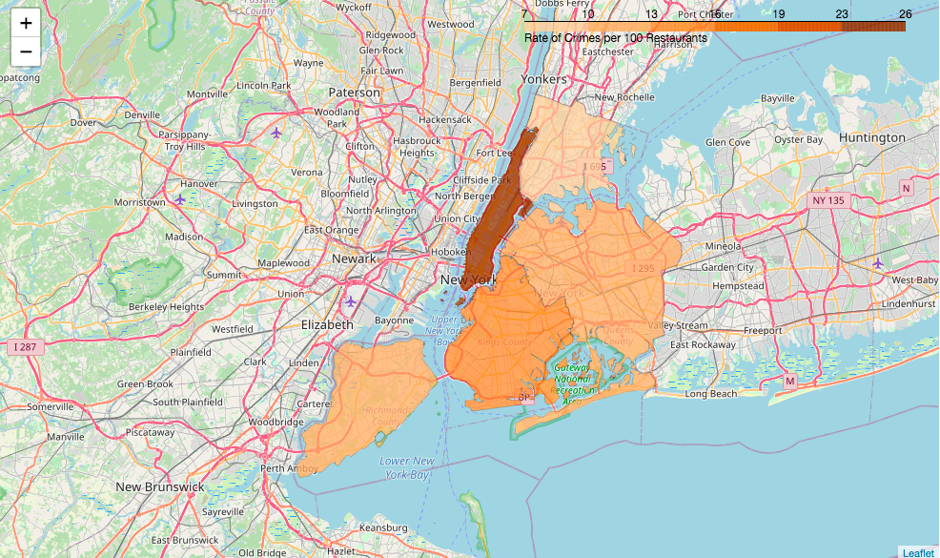

Figure . Choropleth map of crime rate

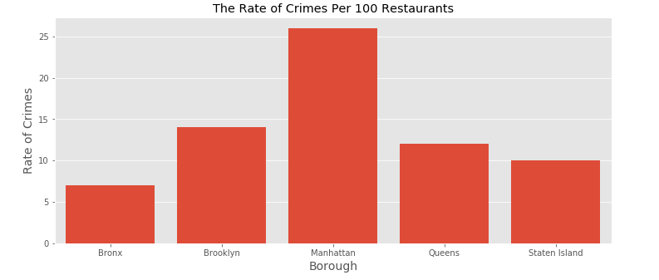

Figure .Bar graph of crime rate per 100 restaurants for each borough

**4. Venue and Crime Clustering Using DBSCAN**

The type of machine learning algorithm I chose to use for this project was clustering. I chose clustering due to it being an unsupervised learning algorithm and this helps because the data I was working with had unlabeled data and the unsupervised learning tries to learn on its own and make sense of the data. I chose clustering in particular because I wanted to cluster the areas with high crimes and areas with high competition. Out of all the clustering algorithms I went with DBSCAN (Density-Based Spatial Clustering of Applications with Noise) due to its ability to locate points of high density and put them in clusters while putting points in low density clusters as outliers. This helps separate crime and venue hot spots (high dense areas) from the cold spots (outliers). I chose Staten Island for the clustering and I explain the reason for picking Staten Island in more detail in the results section.

**4.1 Crime Clustering**

There were interesting findings when I did the crime clustering. When I plotted the clusters to a map it shows that the hot spots for the restaurant crimes were at the opposite tips of the borough from each other. As you see in Figure 13 the hot spots are in red and the cold spots are in black. You can see that there are virtually no crime clusters in middle and the crime clusters that are there are the cold spots.

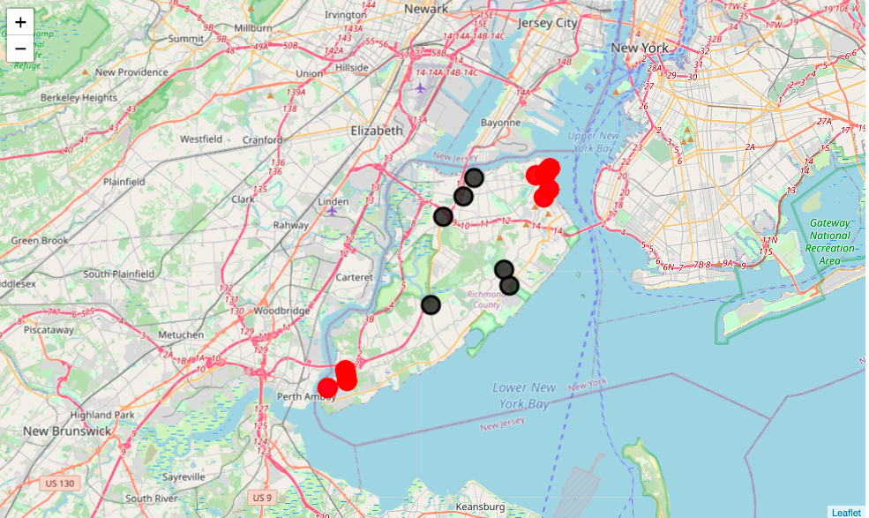

Figure . Map of crime clustering. Clusters are in red and Outliers are in black

**4.1 Competition Clustering**

Similar to crime clustering when I plotted the competition clusters, I noticed some interesting findings. I found that the biggest clusters were toward the north part of Staten Island and the other hot spots had a tend to be closer to the edges of the borough or in other words they are close to the water bodies like Lower New York Bay.

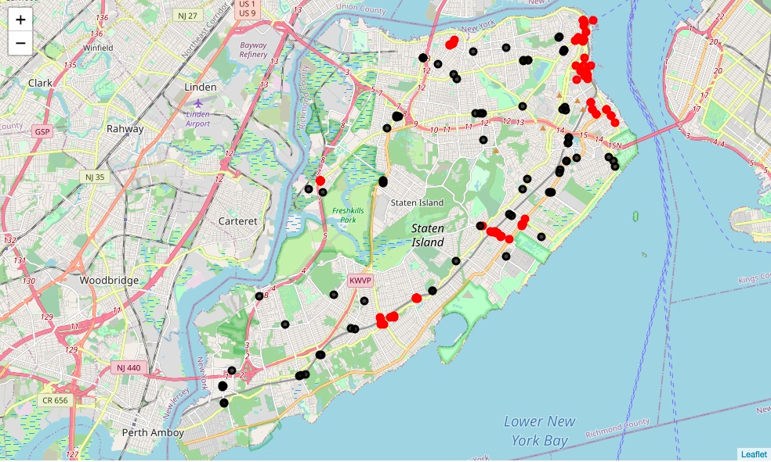

Figure . Map of venues clustering. Clustes arer in red and Outliers are in black

**5. Results and Discussion**

I chose Staten Island as the best borough to relocate or build a restaurant. The reason I chose Staten Island is because it’s one of the safest and has one of the least amounts of competition out of the five boroughs. Even though Staten Island has a higher rate of crime compare to Bronx, the difference between the rates is not that much. Staten Island has rate of 10.1 and Bronx has a rate of 7.0 crimes per 100 restaurants with a difference of only 3.1. Staten Island also has lowest total amount of crimes against restaurants with a total of 16 crimes while the Bronx has a total of 50. Lastly Staten Island has the least amount of competition with a total of 158 restaurant venues which just makes up only 3.78% of the total number of venues across the boroughs. To conclude Staten Island has the least amount of competition and is one of the safest boroughs to relocate a restaurant to.

In Figure 15 you can see in the map 4 different color dots each color has a different meaning. Black are the crime clusters, red is the crime outliers, gray are the venue clusters and blue is the neighborhoods of the venue outliers. Refer to the Table 2 below for the meaning of the colors. The reason why I plotted the outliers as colors that stand out is because those are the cold spots and they are the spots that have the least amount of venues or crimes. I wanted to highlight the crime outliers also to distinguish from the crime clusters. Both the crime outlier and clusters should be avoided when looking for the best location. I made the crime and venue cluster black and gray respectively to highlight the neighborhood outliers. I chose to plot the neighborhoods of the venue outliers instead of the venue outlier because I’m looking for the optimal neighborhoods not necessarily the venues. Even though they’re outliers some of the neighborhoods are still near to the clusters or crime outlier and due to this I highlighted the most optimal neighborhoods and created a list of them refer to Table 3 and I highlighted the neighborhoods in the table with the corresponding group.

Table . Colors and meaning for Figure 15

|  |  |
| --- | --- |
| Color | Meaning |
| Black | Crime Clusters |
| Red | Crime Outliers |
| Gray | Venue Clusters |
| Blue | Neighborhood of the Venue Outliers |

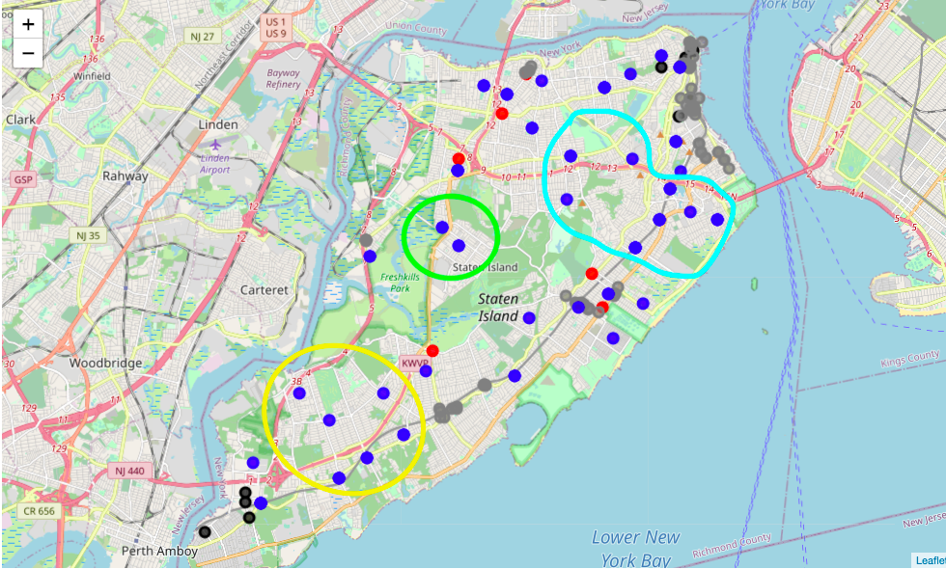

Figure . Map of the crime and venue clusters and crime and the neighborhood outliers

Table . The optimal neighborhoods

|  |
| --- |
| Neighborhoods |
| Rossville |
| Woodrow |
| Prince’s Bay |
| Huguenot |
| Arden Heights |
| Annadale |
|  |
| New Springville |
| Heartland |
|  |
| Manor Heights |
| Castleton Corners |
| Sunnyside |
| Concord  Old Town |
| Dongan Hills |
| Grasmere |
| Arrochar |

**6. Conclusion**

To conclude this report and summarize the key points of the project. The goal was to find the borough and neighborhoods in NYC that is the safest for relocating or building a restaurant while maintaining the least amount of competition. I found that Staten Island is the safest borough with the least amount of competition and a list of the optimal neighborhoods was created to relocate or build a restaurant.